City of El Segundo
COVID-19 Emergency Recovery Plan

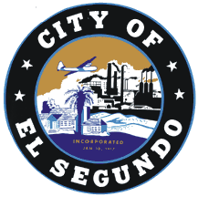

May 2020

Table of Contents

Table of Contents

Vision Statement 2022 2

Introduction 2
Strategic Goals 3
Best Practices 3
The Pillars 4
Organization 6
Concept of Operations 6

Timeframe 8

Conclusion 10

Vision Statement 2022

Two years after the global pandemic COVID-19, social distancing is still a required necessity. On a sunny day, El Segundo residents and residents from across the South Bay and West LA flock to thriving El Segundo. These patrons are enjoying the downtown promenade that was built as a means to allow the restaurants and retailers to expand outside the confines of their walls and serve customers in the Southern California sunshine.
It was El Segundo’s quick actions with a focused sense of urgency to provide aggressive support to its businesses and citizens. While other cities floundered with indecision and was timid about implementing creative programs to recover and develop the economy, El Segundo experienced a different result. El Segundo’s creative implementation of Reserve Your Safety program where businesses across the city implemented appointment times from everything from shopping to eating at restaurants. This minimized the amount of people in any one establishment at the same time, making it safer for the patrons. El Segundo also implemented COVID Clean program where businesses participated in stringent cleaning and disinfectant procedures which attracted customers seeking healthy environments that made them feel safe.
El Segundo was successful at implementing a business preservation program that provided low interest loans and grants to affected businesses that enabled hundreds of businesses that would have closed to persevere through the challenging time. These measures kept businesses functioning, and people employed which ultimately replenished the funds used for the loan program through sales tax and tenant occupancy tax due to hotels, retail, and restaurants reimagined for the provision of safe and healthy amenities.
El Segundo responded quickly, creatively, and utilized outside the box thinking to adapt to the new environment. The creative recovery programs kept businesses operating and kept workers employed. Simultaneously, by providing services in a manner that helped a disease frightened population feeling comfortable about frequenting establishments, El Segundo recovered and began to prosper after the worst economic disaster in a century.

Introduction

The global pandemic resulting from the outbreak of the novel coronavirus beginning in 2019 (COVID-19) has resulted in unprecedented and continuing impacts upon the El Segundo community. The primary impacts of the pandemic from contagion and mitigation efforts resulting in closure of schools and businesses, travel bans, and prohibitions of gatherings to name a few have had secondary effects upon El Segundo. Some of those secondary effects have been empty hotels and visitors, reduced retail sales, reduced production of oil from the Chevron refinery, and empty office buildings. These effects have made tertiary impacts that include loss of revenue to El Segundo government, businesses, job losses of residents, and financial distress. This current situation will arguably be the biggest challenge ever faced by the City of El Segundo. The ultimate goal will be for El Segundo to adapt to the new environment, retain its current businesses, and attract new businesses in a manner consistent with providing health and safety and thus enticing business and patrons to El Segundo.
This recovery plan will be implemented with and supported by six primary pillars. Listed in no priority order, the pillars are: city facilities and programs; city operations; business economic recovery; community recovery; public communications; and government economic recovery. The plan will be implemented in stages with short term goals, medium term goals, and objectives met over the long term. The plan will also be subject to the limitations of new and updated health orders that may materialize based on oscillating conditions of COVID-19 because second and potentially even more subsequent waves of COVID-19 peaks can be expected.
The desired end state and result of this plan is to help residents and businesses recover from the devastating impacts; adapt to the new conditions existing from the pandemic; and proliferate ultimately resulting in El Segundo being recognized as a healthy and safe place to live, work and visit because with retail and restaurants reimagined and a continued location for businesses small and large from which big ideas can take off.

Strategic Goals

Ensure the Health and Safety of the public and employees.

Enable El Segundo to be a place where businesses can thrive and inhibit business closures and employee layoffs.

Keep residents, business stakeholders, and patrons informed about El Segundo recovery activities.

Assist El Segundo residents to overcome hardships brought on by the COVID-19 pandemic.

Prepare El Segundo government facilities and operations to function while taking measures to mitigate COVID-19 transmission issues.

Open community facilities and schedule community activities in a manner that accounts for COVID-19 transmission issues.

Operate and document expenditures in a manner that will enable the emergency management and finance department to maximize reimbursements from Federal Emergency Management Agency and California Office of Emergency Services.

Seek and obtain other governmental relief opportunities.

Best Practices

Some best practices of disaster recovery and economic revival after the impacts of crisis include:

Provide access to funding resources for businesses and communicate this method to eligible applicants.

Provide incentives and assistance to retain employees and keep businesses functioning.

Utilize an All-Hazards Incident Management Team (AHIMT) to coordinate recovery activities and programs.

Implement a strong communications system.

The Pillars

Six pillars will be the foundation of recovery for El Segundo. Below is a synopsis of how each pillar will support the overall strategy of recovery.

Pillar 1: Community Facilities and Programs

Community facilities and programs will be tasked with reopening the closed city services and activities with an emphasis on doing so in a manner that mitigates COVID-19 transmission. Reopening the parks, beach, and other community facilities. Opening can only occur with strong social distancing protocols. These protocols may include protective measures for city staff at those facilities; limiting crowding by requiring reservations; disinfecting facilities; changing environmental aspects of the facility. This pillar will also focus on conducting the special activities that El Segundo residents love including the farmer’s market, various summer activities, recreation programs, and government services that have been suspended.

Pillar 2: City Operations

City operations have significantly changed. During the pandemic, the city has utilized work from home options, implemented health screening before entering facilities, and virtual meetings. The city operations pillar will continue to evaluate the opportunities and changes and seek to implement changes that have shown to be more efficient. This pillar will also focus on changes that will continue to mitigate and protect employees from the spread of COVID-19. Many of these issues can become sensitive due to union concerns, individual protections and privacy, and legal parameters. The goal of this pillar will be to find a way to provide superior government services while implementing protections for the health and safety of the workforce.

Pillar 3: Business Economic Recovery

The business economic recovery pillar could arguably be the largest effort within the recovery plan. Due to the diversity of businesses in El Segundo, this effort will require support and assistance for large businesses and small, retailers and restaurants, commercial office owners and tenants, technological and biomedical, and even startups and centurion businesses. This pillar will focus on providing service and resources to the larger businesses consistent with the abilities of the city. This pillar will also focus on support, aid, assistance, and resources to the smaller businesses. To a larger extent, goals supporting the smaller businesses will be keeping them in business over the long term by assisting in gaining customers and consumers visiting their establishments. This pillar will lead with a marketing campaign that helps to attract people to El Segundo for business and pleasure with the intent of increasing consumer confidence for businesses within El Segundo.

Pillar 4: Community Recovery

The community recovery pillar will focus on social services for families and individuals. El Segundo will assist individuals and families with locating services such as medical and dental, childcare, funeral and burial, rental and mortgage assistance, and job search assistance. This pillar will make known resources available to individuals. This pillar will also help to coordinate donations and philanthropic provisions to needs that originate within the community.

Pillar 5: Government Economic Recovery

The City of El Segundo Government was not immune to the effects of COVID-19. It has suffered a loss in revenues and has spent a deal of unbudgeted funds in response to the pandemic. Within this pillar, El Segundo will seek to recoup, to the extent possible, funding through federal and state assistance programs. This pillar endeavor to shrink the loss of revenue, identify ways to operate more cost effectively in the future, and obtain as much federal reimbursement for eligible response costs.

Pillar 6: Technical Assistance

This pandemic is the result of a novel coronavirus, meaning it is a new virus from which we as a global community know very little about. In the response phase, it was an overwhelming task to stay informed about developing information and protective measures. Information changed daily with regards to social distancing, face coverings, personal protective equipment, health and administrative orders, and social issues. In order for El Segundo to market itself as a healthy and safe place to live and work, it will need to keep current on the dynamic issues while at the same time interpreting them and assisting local businesses and organizations with implementing them. Re-opening businesses will need assistance with site surveys and site safety plans that help to implement the Los Angeles County Department of Public Health and Centers for Disease Control and Prevention best practices. The technical assistance pillar will provide assistance to El Segundo community stakeholders in understanding and implementing COVID-19 related requirements.

Pillar 7: Public Communications

Public communications may have been the most critical component to the positive appearance of El Segundo actions in the response phase. The AHIMT, through the Public Information Office, utilizing El Segundo TV, the El Segundo website, social media, the Everbridge mass notification system, and a joint information center has effectively controlled the information. As the transition from response to recovery occurs, public communications may continue to be the most critical piece of the recovery operation. El Segundo can implement many operations and resources, but if the public does not know about it, it would be all for not. The recovery will need to absorb the continuous changing information pertaining to issues and protocols and communicate them to the public. The challenge is to address this global issue and coordinate the national, state, and county information and then message it in a consistent manner. As health orders change and new information about COVID-19 emerges, public information will experience an increasing number of tasks to achieve effective communications. This will also require a seven-day a week operation.

Organization

As demonstrated by the successful response phase, the AHIMT is instrumental as a force multiplier for all city departments. The AHIMT manages the COVID-19 related issues allowing departments to focus on the specific charter of their organization. This will not change in the recovery phase. Furthermore, utilizing the AHIMT will allow for greater coordination and collaboration across departments facilitating strength in recovery while reducing duplication of effort. Below is an organizational chart of the recovery organization.

Concept of Operations

With this organization, the following concept of operations will be utilized to ensure the greatest collaboration between the various organizational elements and the greatest efficiency in support of the residents and workers of the City of El Segundo. Mutually supporting organizations will be key to this strategy. Information sharing between elements will be key to mutually supporting organizational elements. The sharing of information will be facilitated by meetings, informal communications, and the intentional and continuous use of the VEOCI crisis management software so all people can see what is happening in each area to enable the planning section to produce effective situation reports.
In the recovery phase, the AHIMT will shift to seven-day operational periods, meaning they will cycle through the planning process only one day a week, thus allowing for more focused time on operational work and allowing tasks to be completed toward objectives. In this meeting, the general tasks of the week will be defined and documented within each division/group ICS 204 form. That ICS 204 form will tell everyone on the team what the primary line of effort or area of focus is for the week.
Team meetings involving group supervisors and command and general staff will be conducted daily at first and then as necessary as operational tempo requires later. Meetings will be run by the Planning Section Chief and are intended to ensure effective information exchange. In each meeting, each group will be asked to give a report on their line of effort, answer what their needs are, answer what information needs to be shared with the public, and answer what their challenges have been.
The Public Safety Branch will continue to operate similar to the way that it has. Park Vista remains our number one vulnerability and we will continue to take as many proactive steps as practical to prevent an outbreak within the community. The police and fire departments will continue to operate with its new normal COVID-19 operational procedures.
The Community Facilities and Activities group will identify their tasks based on an analysis of health orders and determine exactly what facilities and activities they can reopen. They can take advantage of the technical assistance group. They will use the PIO to communicate reopening’s and scheduled activities along with special instructions to people who intend to attend or participate in those facilities’ or activities.
The City Operations Group will focus on opening city facilities and identifying and instituting new operational protocols. These could range from entrance to city facility procedures to reclassifying jobs to be full time or part time work at home. The new protocols may include continuing current practices such as keeping City Hall closed and only open by appointment. Once again, these decisions are information that must be disseminated to both the public and our employees and should be routed to the PIO for dissemination in an overall strategy.
The Technical Assistance Group will provide assistance to those in need of understanding and implementing guidance and best practices from the health orders, the Los Angeles County Department of Public Health, and the Centers for Disease Control and Prevention. This will be a resource for our own city facilities and operations, the private sector including both large and small businesses, and the nonprofit sector.
The Business Recovery Group will focus on both large and small private sector businesses. To the extent that the city can make changes and provide exemptions or make environmental changes to support business growth, this group will work with the other city departments to fast-track and break down bureaucracy to the extent possible. If it possible for donations, grants, or other funding to be made available, the Business Recovery Group will provide assistance in making such support available.
The Community Recovery Group will focus on making social services and resources available to the individuals and families within the community. The group will work with a coalition of philanthropic organizations to identify donated goods and services that can be made available to those in need. In order to maximize donations, especially goods or services in short supply, the group will need to work closely with the PIO to communicate those needs to the community as a whole.
The government recovery group will primarily be focused on reimbursements from the FEMA Public Assistance Category B grant and potential funding from the California Disaster Assistance Act. The primary stakeholders in this endeavor are the Documentation Unit with the Planning Section, the Logistics Section, the Finance and Administration Section, the Emergency Management Coordinator, and the Finance Department. Together, these entities will seek to recoup as much funding as possible from our response costs. This group will also seek other available relief funding from other programs to help support government recovery.

Timeframe

The implementation timeframe is somewhat complex. First, it is known that social distancing and other mitigation practices are expected to be necessary well into the year 2022. Additionally, it is believed that the U.S. (and the world) will experience another spike, which could be more severe than the first outbreak and there is even speculation of three or four spikes. El Segundo is also at the mercy of the Los Angeles County Health Officer in terms of when businesses are allowed to reopen or close again during the anticipated second and potential subsequent spike(s). Therefore, it is difficult to determine what kind of barriers may present themselves as COVID-19 ebbs and flows as an economy affecting virus. Nonetheless, this plan will seek to implement recovery phases over six months (short-term), one year (mid-term), and eighteen months (long-term), but recovery plan objectives will be flexible and in alignment with the following planned reopening process shown below:

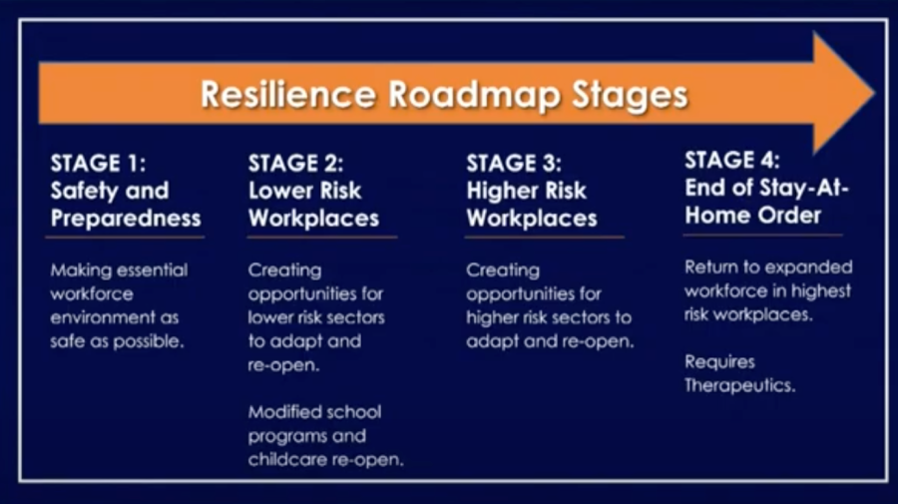
The El Segundo timeframe is at the mercy of the County Health Officer and the California Governor. Despite the ambiguity, this plan will estimate that Stage 2 will begin on May 15th, 2020 which will be the trigger for El Segundo to initiate this recovery plan beginning the six-month short-term goals which will include emphasis on:

- Non-essential manufacturing (toys, furniture, clothing, etc.)

- Schools

- Childcare facilities

- Retail businesses for curbside pick-up

- Offices where working remotely isn't possible, but can be modified to make the environment safer for employees

Phase 2, estimated to be between October 2020 and April 2021 will focus on the following business priorities:

- Hair salons

- Nail salons

- Gyms

- Movie theaters

- Sporting events without live audiences

- In-person religious services (places of worship)

The final phase, Phase 3, is estimated to be implemented between May 2021 and November 2021 and will focus on the following business priorities:

- Concert venues

- Convention centers

- Sporting events with live audiences

Conclusion

The COVID-19 global pandemic has challenged the economy of El Segundo like no other disaster could. Businesses have been out of operation since the onset of the pandemic with more time still to come. Many financial issues experienced are not covered by insurance policies. Lost revenue has played a big role in damaging large businesses, small businesses, and the government. In order to recover, El Segundo must adapt to the changed environment and take aggressive steps to defend the city of businesses crumbling. It must find a way to keep businesses open and attract consumers to the city to grow revenue for the businesses and for the government. Implementing this plan is the first step to the road to recovery.

